## **1.0 Reagent preparation**

**1.1 Ammonium molybdate solution**

|  |  |  |  |
| --- | --- | --- | --- |
| Ammonium molybdate | 1.8 g | 0.9 g | 0.45 g |
| Sulfuric acid | 22.3 mL | 11.15 mL | 5.575 mL |
| Antimony potassium tartrate | 0.05 g | 0.025 g | 0.0125 g |
| Sodium dodecyl sulfate | 2 g | 1 g | 0.5 g |
| DI water | 1000 mL | 500 mL | 250 mL |

**1.2 Ascorbic acid solution**

|  |  |  |  |
| --- | --- | --- | --- |
| Ascorbic acid | 15 g | 7.5 g | 3.75 g |
| DI water | 1000 mL | 500 mL | 250 mL |

**1.3 SDS solution**

|  |  |  |  |
| --- | --- | --- | --- |
| Sodium dodecyl sulfate | 2 g | 1 g | 0.5 g |
| DI water | 1000 mL | 500 mL | 250 mL |

**1.4 Standards, blanks and check samples**

- Prepare standards in the 0.01 – 6 ppm range using KH2PO4. There is room for 10 standards.

- Prepare a blank using just MilliQ water. Run the blank as the first standard, as well as a sample.

- Prepare a check sample using H3PO4 CRM.

## **2.0 Starting the machine**

* Turn black power bar at the back of the instrument on.
* Remove dust covers.
* Inspect tubing for signs of damage or dirt. Replace any tubing if needed.
* Place each pump tube in its respective solution. See marks on the sampling lines, as well as Figure 1 in the figures section.
* Tighten the tubes, and make sure they are parallel to one another.
* Attach the platen.
* Turn on the computer (and fill in the log book).
* Open the AACE6.10 software.
* Start charting. (Previous run is ok for now).
* Start the pump by hitting the red button. Let solutions flow through the system for about 10 mins. The setting can be switched to ‘fast’ during this time. The spectrometer will also warm up during this time.
* Place standards in their racks, preferably from lowest to highest. 901 will be blank.
* Place samples in the sample rack.

## **3.0 Setting up a new run**

While the machine is warming up, you can setup a new run on the software.

* Go to Set Up > Analysis/Run
* Click ‘New Analysis’. Choose System 1.
* Fill the Main Page tab. See Figure 2 in the figure section for details. (Method 2 can be deleted.)
* Fill in Channel 1 tab. See Figure 3 in the figure section for details. Note: start standards from 0 ppm, not 50 ppb.
* Set up the Tray Protocol tab. See Figure 4 in the figures section for details.   
  You can also load a tray from previous run and modify it.
* Save the tray after setting it up.
* Close the screen. Say ‘yes’ to “Do you want to create a run?”
* Close the old charting screen. Click on ‘Charting’ again. Make sure the method you saved is the one that is currently active.
* Close Ch.2-1 -.
* Switch pump to ‘normal’ pace.
* Right click in the chart area and ‘Set light power’. This will take a few seconds.
* Right click and ‘set base’. You should just be running water as a sample, and reagents during all this.
* Wait for the baseline to become stable. The graph should be a stable continuous line.
* Double click on ‘XY2 Sampler 1’. Make the sampling probe go into the highest standard.   
  After 1 minute, it can be switched back to wash.
* Wait for the highest standard peak to show up. It’ll take about 12-15 mins to show up. Don’t miss it!
* When you see the peak, right click and ‘Set Gain’.
* Now you can hit ‘run’ and start your analysis. You may start a new charting session if you like.

## **4.0 Clean-up**

* Put all lines in the water and let run for 5 mins on ‘fast’ speed.
* Inject 3% H2SO4 as a sample for 5 mins.
* Then put the probe back in the wash line for 5 mins.
* Turn off the switch on the power bar.
* Take off the platen.
* Loosen the sampling lines
* Put the dust covers on.
* Put all reagents away.

## **5.0 Figures**

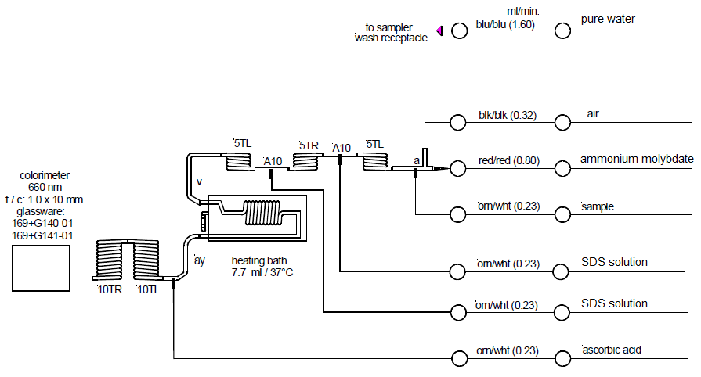

Figure . Schematic of the AA instrumentation. Taken and modified from Method No. G-103-93 Rev. 10, page 11.

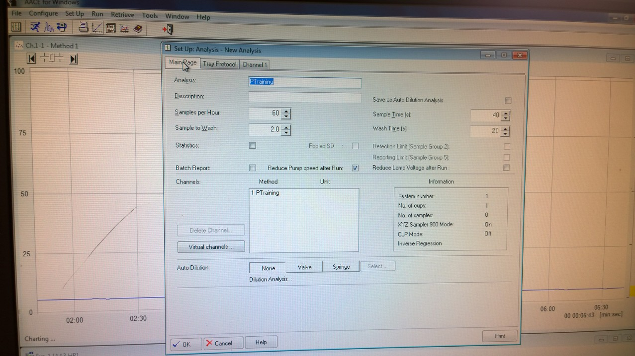

Figure . Method Page set-up.

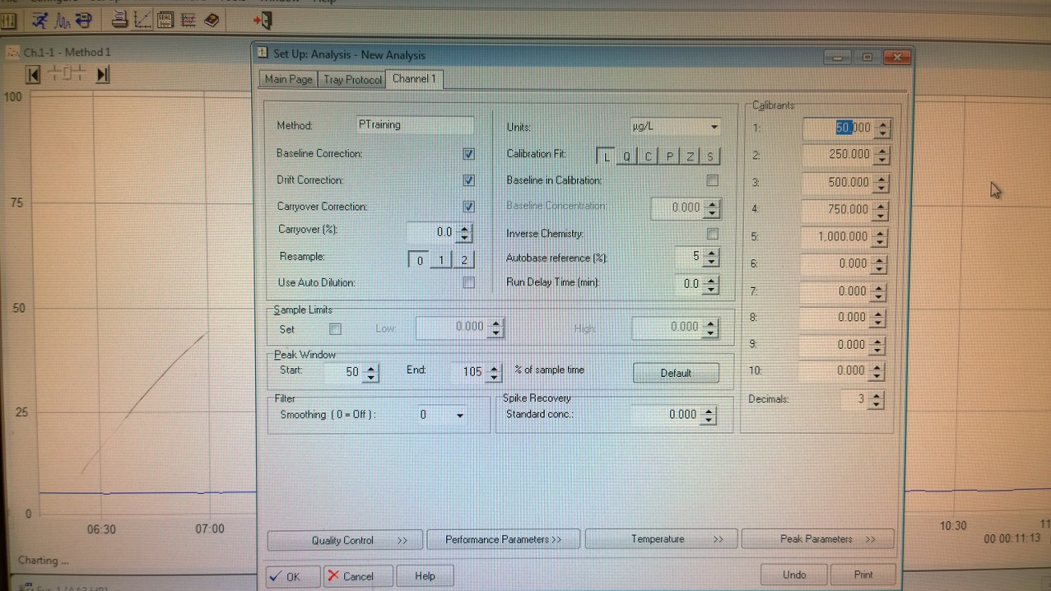

Figure . Channel 1 set-up.

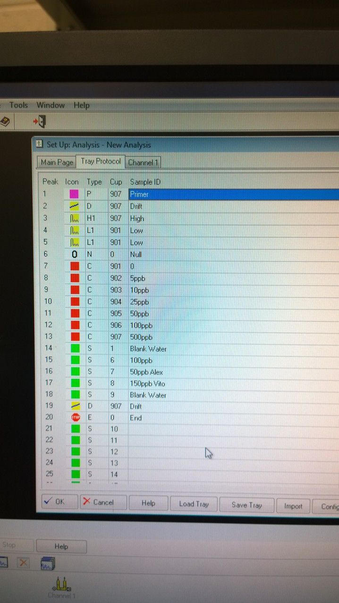

Figure . Tray Protocol set-up.